**U-ME Capital (CARE Vietnam)**

**Team Assessment**

**Team Members**

Introducing Team U-ME Capital:

* Takara Team Captain/Country Program and Business Development Advisor
* Nga Co-Captain/Private Sector Engagement Specialist
* Huong SMP Socially Marginalized Population Team Leader
* Huong WEE Women’s Economic Empowerment Specialist
* Ngan Program Officer
* Ly Gender Officer
* Hai ICT Specialist

**Profiles**

**Name:** Takara Morgan

**LinkedIn:** <https://www.linkedin.com/in/takara-morgan-bbab4133/>

**Background:** Takara has more than eight years’ experience in international development (with the UN, IOM, and CARE) and holds a Masters of Applied Anthropology and Participatory Development. Takara started working with CARE Australia in January 2011 and most recently held the Asia Coordinator role before moving to CARE Vietnam in November 2017.

**Role:** In CARE Vietnam, Takara is the Country Program and Business Development Advisor. She led on the development of the U-ME Capital concept and is also the co-captain. Takara is an experienced project coordinator across diverse sectors with a keen interest in private sector approaches to development. She is also an intrapreneur, problem solver, and avid learner. At the heart of her approach is a strong focus on supporting staff to think differently and innovatively about the way CARE does its work to ensure maximum benefit and impact for project participants, particularly women and girls and people with disabilities.

**Accommodations:** No accommodations are required.

**Name:** Nga Ha Thi Quynh (Nga)

**Background:** Nga is currently the Private Sector Engagement Specialist. She is working towards gaining support from and influencing the private sector to bring about sustainable change to the lives of vulnerable communities, particularly women. Nga previously was the Coordinator of the Vietnam NGO Climate Change Working Group (CCWG) and Disaster Management Working Group (DMWG). She managed the Southern Voices Capacity Building Programme, aiming at increasing local networks’ capacity and advocating climate change policies. Prior to joining CARE in September 2012, Nga was the Youth Programme Coordinator at Live & Learn Vietnam where she successfully engaged thousands of youth in 22 cities and provinces across Vietnam. Nga was selected as climate leader by British Council and acted as a focal point for ASEAN Youth Movement in Vietnam in 2010. Nga got her B.A degree in International Studies from Hanoi University in 2007.

**Role:** Nga is the Co-Captain of U-ME Capital. In this role, Nga will work to identify market opportunities for U-ME Capital through collaborating with relevant social enterprises and companies which support and provide services for female migrants. Nga will leverage experience from CARE’s global private sector engagement network for cross-learning and sharing from similar initiatives. She will also play a key role in developing the Business Model Canvas in later stage and testify U-ME Capital when it is ready for the market. She will work closely Takara (Team Captain) to get other team members on board and make sure the Country Office fully benefits from this learning journey.

**Accommodations:** No accommodations are required.

**Name:** Nguyen Thi Huong (Huong SMP)

**LinkedIn:** <https://www.linkedin.com/in/hhuong>

**Background:** Hương has 18+ years of experience working collaboratively with governmental and non-governmental agencies, civil society organizations, UN agencies, associations and private sector in social development; as well as experience in developing organizations’ strategic plans, national programs and policy advocacy plans. Huong has a Master of Law in Vietnam and Master of Art on International Development and Social Change in the USA. Huong has been working at CARE as a Program Team Leader of Socially Marginalized Population (SMP) program for two years.

**Role:** In CARE Vietnam, Huong contributes to strategic direction setting and organisational development of CARE Vietnam as a member of the Senior Management Team; Provide leadership and managerial oversight for the SMP program in terms of program strategy and project development, people management; Develop and maintain partnerships and networks with relevant government agencies, international organisations, UN agencies; donor agencies, Vietnamese CSO/CBO partners; Be the thematic lead on SMP advocacy work, country focal point of regional impact growth strategy on dignified work. Huong was a part of design team for U-ME Capital concept.

**Accommodations:** No accommodations are required.

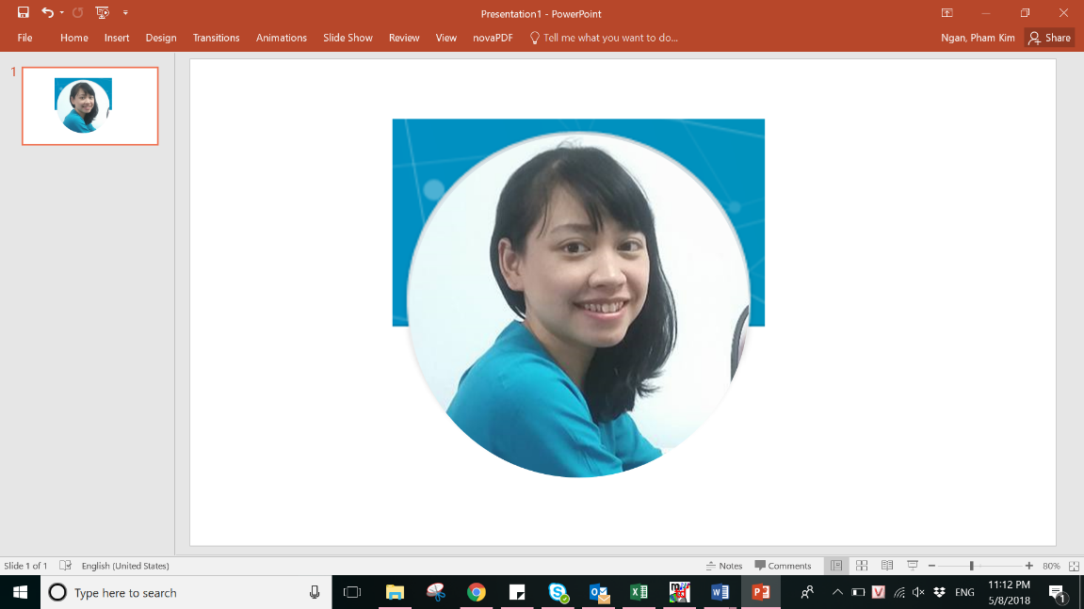

**Name:** Pham Kim Ngan (Ngan)

**LinkedIn:** <https://www.linkedin.com/in/ngan-pham-kim-40091211b/>

**Background:** Ngan’s major is Sociology. She has eight years’ experience in international development with CARE through a number of positions. She is currently working as a Project Officer to support vulnerable groups in urban contexts with a focus on formal migrant workers (e.g. garment factory workers) and informal migrant workers such as street vendors, waste collectors, and seafood processers.

**Role:** Ngan is currently managing two projects focusing on the economic empowerment of female migrants in the informal sector (such as domestic workers, street vendors, and waste collectors). This includes the urban VSLA pilot from which U-ME Capital will draw on.

**Accommodations:** No accommodations are required.

**Name:** Tran Huong Ly (Ly)

**Background:** Ly is a development practitioner with over 6 years of experience in international development with a strong focus on agricultural value chains, gender issues and access to financial services for marginalised groups. Ly joined CARE in Vietnam in December 2017 as a Gender Officer where she has been involved in designing and executing interventions and advocacy activities under Socially Marginalised Program. Ly holds a Bachelor degree in International Development Studies.

**Role:** As a Gender Officer, Ly provides support to U-ME Capital from gender specialist perspective, making sure that U-ME Groups are able to build their social capital and the business model is gender transformative.

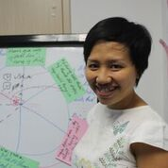**Name:** Vu Lan Huong (Huong WEE)

**Background:** Huong has more than eight years’ experience in development sector, focusing on women empowerment, agriculture and climate change. She is currently the Women’s Economic Empowerment Specialist in CARE Vietnam.

**Role:** Huong will provide significant inputs to scaling out U-ME Groups based on the nascent pilot of VLSA in urban area and implementation of LienVietPostbank’s Vi Viet e-wallet for ethnic minority women. She will also give advices to U-ME App development, particularly on U-ME Earn.

**Name:** Nguyen Viet Hai (Hai)

**Background:** Hai has 15 years working on ICT, with focus on development area (ICT4D).Hai is passionate and always has creative ideas with technology that supports the poor and vulnerable. He also takes advantage of new technology to increase effectiveness.

**Role:** Hai will support the development of U-ME App including U-ME Chat, U-ME Earn and U-ME Learn. He will ensure technology, internet literacy; cyber security is adequately provided to U-ME members. Hai will also work closely with app development experts.

**Profile: U-ME Capital**

**Project Objective:** Urban female migrant workers in Vietnam have increased wellbeing through a safe “one stop shop” platform to identify and take advantage of entrepreneurial and skills development opportunities; manage their finances including saving, loans, and remittances; and to access vital information, contacts, and support services. U-ME Capital will support urban female migrant workers to enhance their financial, social, and human capital and to unite to increase their quality of life and voice in the community.

**Project Description:** U-ME Capital will be a social enterprise offering two value propositions, U-ME App and U-ME Groups.

**U-ME App** is an integrated app which draws off technologies such as Airtasker and Grab and will include three modules:

* U-ME Earn – Migrants register their services, clients advertise jobs they need done, and migrants bid for this work. Individuals can choose to be tracked by GPS by select people as a security function. Service users pay through the app which is transferred to migrants’ LienVietPostBank e-wallet. Service users and service providers rate the service/client and provide written feedback.
* U-ME Learn – training information for anyone offering services through ‘U-ME Earn’ to ensure consistent standards, and links to resources including migrant support services.
* U-ME Chat – a safe space for migrant women to chat about common issues and share events and information.

**U-ME Groups** are collectives of female migrant workers who meet once a month in person (or possibly online). They will save and loan money through CARE’s Village Savings and Loans Associations (VSLA) approach, and learn entrepreneurial and life skills. These skills will enable them to have increased confidence and skills to engage in household and community decision making and to take advantage of economic opportunities.

**Progress Made to Date (pre-SXD Accelerator):** U-ME Capital will leverage CARE’s partnership with LienVietPostBank who have already customized their Vi Viet e-wallet for VSLAs. 172 women from six VSLA groups tested the e-wallet and used it to make deposits, access loans and use other services. Within four months of testing, 2,151 transactions were conducted via Vi Viet with a total value of US$18,024. While it is too early to draw conclusions on the impact of Vi Viet, we have gained some key lessons including the need for a stronger link between wallet usage and income generation activities.

CARE has significant experience combining VSLAs with life skills training in rural settings. A 2017 independent rural project evaluation found the groups help women learn new skills, increase their social solidarity and “VSLA was well-advocated for replication.” The success of the LARC/VSLA model was demonstrated by partners replicating 52 VSLAs in three rural provinces (non-project locations) doubling the number of groups the project intended to reach. Another project evaluation found that

85.5% of participants’ income improved thanks to savings and loans practices.

CARE is currently piloting urban VSLAs in Hanoi. The project is small scale but has shown promise among seafood sellers, waste collectors, and street vendors.

**Accelerator Outcomes:** Through the accelerator we are looking to achieve a few things:

* Staff are equipped with the knowledge and tools to:
  + Better understand the needs of the end user and the problem we are trying to address
  + Think differently about the way we do our work and think “outside the box” and beyond what is already in the market
  + Develop an innovation which is designed for scale from the beginning
* Innovation further defined and refined, ready for pitching to potential investors

**Moving Forward:** CARE is looking to build on existing work with LienVietPostBank in rural contexts and nascent VSLA and life skills training in urban contexts to prototype the innovation as one integrated approach. The intention is to design for scale right from the beginning.

With catalytic funding and inputs from financial inclusion, entrepreneurship, and social enterprise experts as well as app developers, it is expected that U-ME Capital will provide a comprehensive solution for urban female migrant workers.

Once the prototype has been refined and there is proof of concept, CARE will establish a social enterprise to scale and sustain the innovation.

**Innovation**

1. **Background documents**

U-ME Capital is a new idea which kind of merges a small scale urban project focused on VSLAs (called NEW ME which is funded by The Asia Group Foundation and Pieirls Foundation as well as UPS), and a nascent rural project working with LienVietPost Bank (FinLINK which is funded by VISA), but then takes it to a whole new level. Therefore there is no one document that consolidates our thinking besides the application! That said, we have attached the recent final report on FinLINK. From NEW ME, we have also attached the final report from Phase 2, the proposal for phase 3 (just received US$20,000 for this project from The Asia Group) and a case study. The team is currently working on a case study for FinLINK which we can share once available.

1. **Have you already started the process of scaling up? If so, what has been accomplished?**

No, we have not started scaling up. We are still at the prototyping stage. Therefore, we need to refine our idea through the ScaleXDesign learning process, test it, and then scale (if feasible). U-ME Capital is currently an idea which needs to be tested further with end users. It is early days for the innovation but we think it has good potential. We will also continue exploring possible partnerships during the ScaleXDesign process, for example, Nga (co-captain) was recently introduced to an organization, [jupviec.vn](https://www.jupviec.vn/), which is providing a job matching service for domestic workers.

1. **What are your team goals for scaling?**

As above, we first need to be clear on what exactly we are scaling first. U-ME Capital currently has the potential to go down a few different paths. However, based on our submission, our overall goal would be for U-ME Capital to be a platform that female migrant workers can’t live without – whether that be for accessing savings and loans, learning about job opportunities (and having a mechanism to ensure their safety), chatting about current issues with fellow migrant workers, or accessing migrant services. We want U-ME Capital to be the “one-stop shop” for all female migrant workers throughout Vietnam.

Through the ScaleXDesign, we hope to learn about new ideas and methods for designing innovative projects, and generally to be challenged to think differently about the way we do our work. After the ScaleXDesign, we hope to have a well-defined idea that project participants can’t live without and which excites CARE staff and potential investors.

After that, we hope to secure funding to test our idea and then take it to scale! The possibilities of FinTech, particularly in emerging economies in Asia, including Vietnam, are almost endless at the moment. The U-ME Capital team hopes we can leverage these opportunities to support female migrant workers while also supporting CARE’s women’s economic empowerment ambitions.

1. **Five years from now, how far do you expect scaling to have progressed?**

There is huge potential in FinTech in Asia. With the right partners, mentors, and investment, the idea, particularly the digitized VSLA component, could really take off. Realistically:

* 2018/2019: ScaleXDesign Challenge – learning and refinement of the idea
* Mid-late 2019: Secure funding to conduct a pilot of U-ME Capital
* 2020/2021 Prototyping/piloting of U-ME Capital, 1000 downloads, 800 active users
* 2022 Further investment to start scaling up U-ME Capital – 3,000 downloads, 2,000

active users

* 2023 10,000 downloads of U-ME Capital App, 8,000 active users

Please note these are estimates based on regular project-based projections and us not having an in-depth knowledge of the potential scale for an app-based solution! We are hoping that this is a highly replicable approach which could reach far higher numbers then that listed here as per the Program Strategy and potentially be something that could be replicated internationally with a banking partner.

1. **In the application, we asked about the biggest barrier to scale. Are there additional barriers we should be thinking about?**

In our application, we mentioned that maintaining social capital among a diverse population would be the biggest barrier. U-ME Capital is an idea at the moment so needs further research and testing before genuinely thinking about scaling. If it catches on though, we think it could scale quickly.

1. **If your team could prioritise learning new information or a new set of skills that would help you take the innovation to scale, what would it be?**

* We are concerned if our business model is viable financially and operationally. For example, when and how we are able to earn income, how we will sustain our revenue streams (financial model), how long it will take until break-even;
* How to make sure the solution can really meet the needs of female migrants and bring about changes we expected;
* How to develop convincing pitch/value propositions to potential donors and investors
* How to conduct analysis on competitors in the market
* Management skills to set-up a new social enterprise
* How to fine tune the solution and take it to scale, what conditions are needed for scale.

1. **If your team had access to a mentor that would support you on a particular issue, what would that issue be, and what knowledge, skills, and connections would that mentor have?**

We would expect that the person has experience in app development, mobile technology, or market analysis. The U-ME App should take into account lessons from other similar apps and is easily accessible for those with low levels of literacy.

1. **If your team had access to a consultant or vendor support, what would you hire that consultant to** do?

We would expect the consultant to:

* To support the team members to better understand the needs of end-users (female migrants) to inform the development of U-ME App
* To support the development of a viable business model which is feasible for the Country Office
* To help with financial modeling of U-ME Capital
* To advise on practical steps to test the market and officially launch the solution

1. **What else? Is there anything else you would like to tell us?**

For the Accelerator Outcomes, we didn’t list in that section, we are also keen to get clarity on whether the idea is ready for scale or whether we need to stay at the prototyping and proof of concept stages before we think too much about scaling. We need consider scaling for design from the beginning of course but some other ideas in the cohort seem further advanced.

In May, Takara joined the Asia Pacific Program Leadership Team meeting in Bangkok where regional colleagues talked about impact at scale, among other topics. Listening to a colleague talk about the different stages of product development (prototyping, proof of concept, piloting, and production), Takara was questioning whether we are ready for scale. Perhaps Takara is just getting cold feet! Whitney or Savannah, it would be great to hear your thoughts. Happy to chat!